Aamir Rahman

CS 405 Secure Coding

4/2/023

5-2 Activity: Encryption Coding

Before code edit:



After code edit:

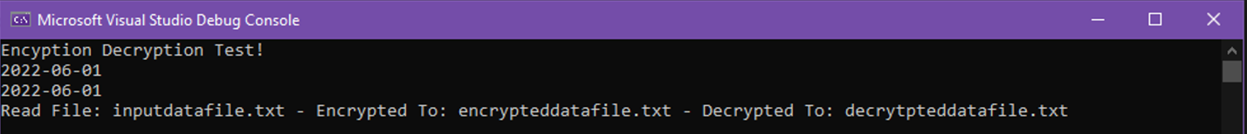

For the first TODO, I added ^ key[i % key_length]. The second TODO area in std::string read_file, I added a try/catch to read the file, open it, get the line, and then close the file. If the file could not be read, I put a failure message stating the file failed to be read as a way to tell the user what is going on. Then for void save_data_file, I did another try/catch/if to open the file, write the student’s name, the time as of the program running (local time), wrote the key, wrote the data, and then closed the file once that all ran. If it failed, I put a warning message stating that the file failed to write to let the user know if it failed. This is a summary of the process that I followed to complete this assignment.